PRACTICAL 2A
Create an api for creating and viewing todo items using flask
Aim: To-Do List REST API using Flask

Code:

from flask import Flask, request, jsonify

import datetime

app = Flask(__name__)

todos = []
next_id = 1
@app.route('/todos',methods=['POST'])
def create_todo():
global next_id
data = request.get_json()

task = data.get('task')
status = data.get('status')
date = datetime.datetime.now()

if task is None:
return jsonify({'error':'Task is required'}),400

new_todo = {
'id': next_id,
'task': task,
'date': date,
'status': status
}

todos.append(new_todo)
next_id += 1

return "task added", 201

@app.route('/todos', methods=['GET'])
def get_todos():
return jsonify(todos)

@app.route('/todos/<int:todo_id>', methods=['GET'])
def get_todo(todo_id):

todo = next(
(todo for todo in todos if todo['id'] == todo_id),
None
)

if todo is None:
return jsonify({'error': 'Todo not found'}), 404

return jsonify(todo)

@app.route('/todos/<int:todo_id>', methods=['PUT'])
def update_todo(todo_id):

data = request.get_json()
task = data.get('task')

if task is None:
return jsonify({'error': 'Todo is required'}), 400

todo = next(
(todo for todo in todos if todo['id'] == todo_id),
None
)

if todo is None:
return jsonify({'error': 'Todo not found'}), 404

todo['task'] = task

return jsonify(todo)

@app.route('/todos/<int:todo_id>', methods=['DELETE'])
def delete_todo(todo_id):

global todos

todos = [
todo for todo in todos
if todo['id'] != todo_id
]

return jsonify("TASK DELETED")

if __name__ == '__main__':
app.run(debug=True)
OUTPUT:
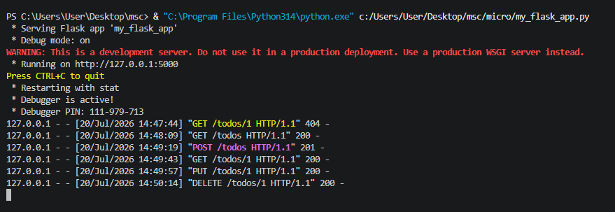

4. Running the Flask Server
Use IDLE or terminal to run the file:
python my_flask_app.py
Access the API in browser at http://127.0.0.1:5000/
5. Testing the API
{ "task": "Complete practical", "status": "pending" }
6. Output
- First visit to `/todos` showed empty list: []
- After POST request, GET `/todos` showed the added tasks in JSON format.
Testing POST Request using Postman
Objective:
Add a new task to the To-Do API using a POST request via Postman tool.
Steps:
1. Open Postman application on your system.
2. Set Request Type to POST from the dropdown.
3. In the URL bar, enter:
http://127.0.0.1:5000/todos
1. Click on the Body tab.
2. Select the raw option.
3. From the dropdown next to raw, select JSON (application/json).
4. Enter the JSON body as:
{ "task": "Do Task",
"status": "pending" }
5. Click the Send button.
Output:
Status: 201 CREATED • Server responded with a message:
{
"message": "Task added successfully!",
"todo": {
"id": 1,
"task": "Do Task",
"status": "pending",
"date": "2025-07-22 08:47:55"
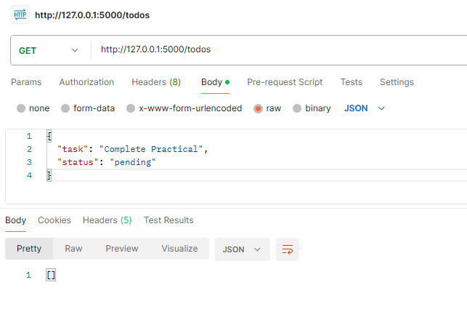
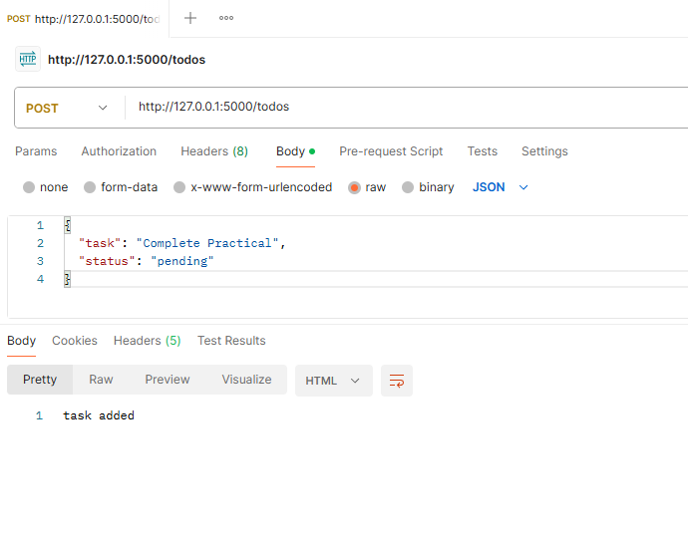
}
OUTPUT OF POSTMAN:

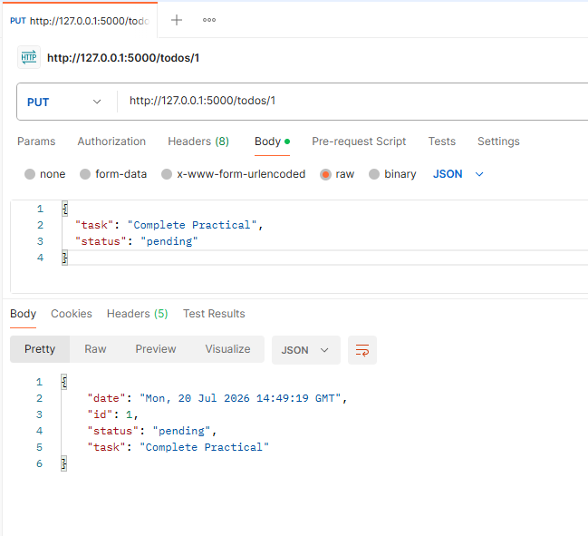
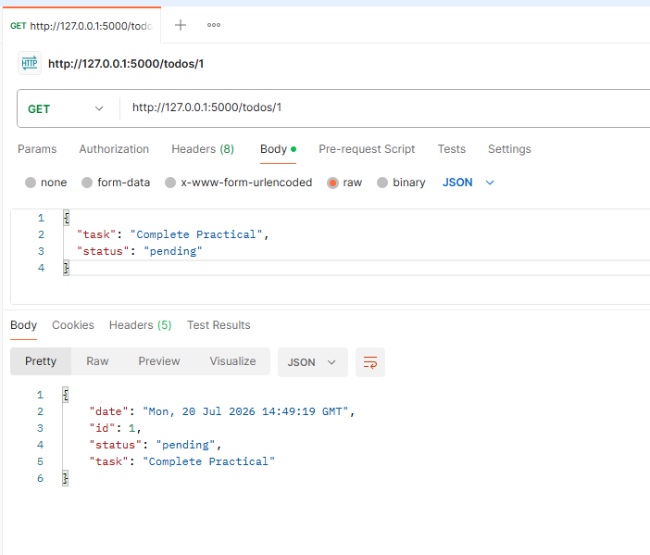
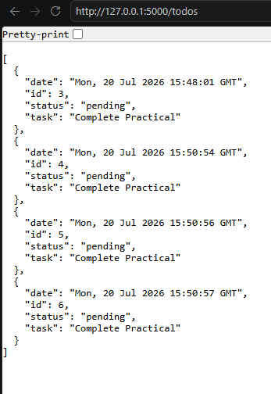
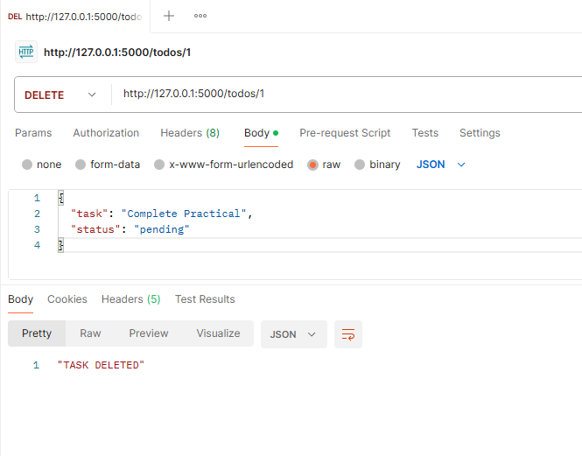

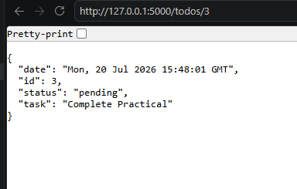

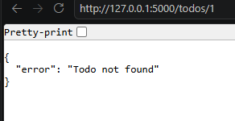

PRACTICAL 2B
Daily Water Intake Tracking REST API using FastAPI

Aim: To design and implement a RESTful API using FastAPI that allows users to log their daily water intake and retrieve stored water consumption records through HTTP requests.

Objectives
- To understand the basics of FastAPI and REST APIs.
- To create API endpoints for storing water intake data.
- To retrieve logged water intake records using GET requests.
- To validate user input using Pydantic models.

Requirements
- Python 3.x
- FastAPI
- Uvicorn

Installation Command

Installation Command
pip install fastapi uvicorn
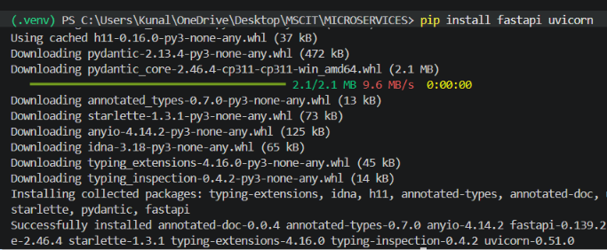

Code:
from fastapi import FastAPI
from pydantic import BaseModel
from typing import List

app = FastAPI()

# In-memory storage
water_data = []

class WaterIntake(BaseModel):
date: str
amount_liters: float

# Add water intake record
@app.post("/water/")
def add_water_intake(record: WaterIntake):
water_data.append(record)
return {"message": "Water intake logged successfully"}

# Get all water intake records
@app.get("/water/", response_model=List[WaterIntake])
def get_water_intake():
return water_data

Step 1: Start the FastAPI Server
Open VS Code Terminal and run:
python -m uvicorn main:app --reload
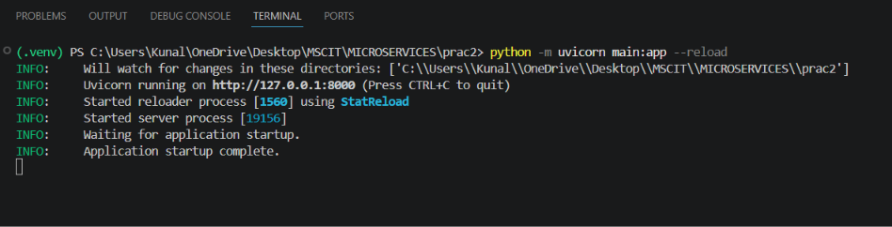
You should see:
INFO: Uvicorn running on http://127.0.0.1:8000
Do not close this terminal.

Step 2: Open Postman
Open Postman and click New Request.

Step 3: Test GET Request

Purpose
Retrieve all water intake records.

Procedure
- Select GET from the dropdown.
- Enter the URL:
http://127.0.0.1:8000/water/
- Click Send.

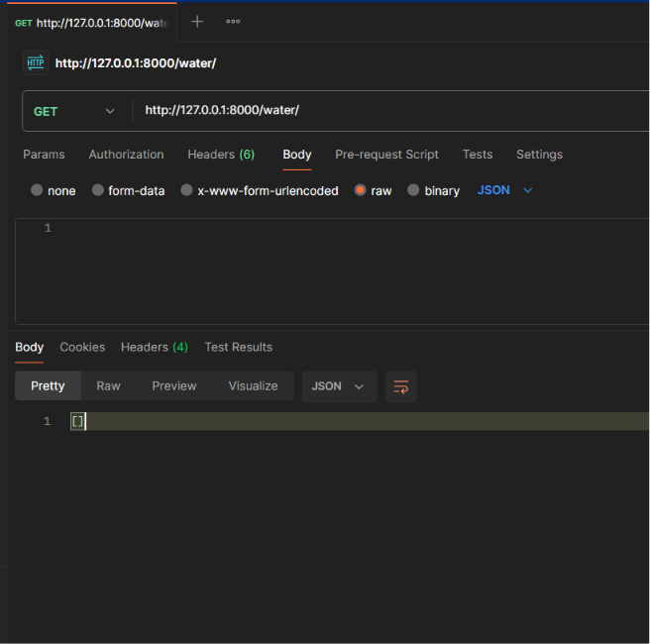
Expected Output
This means no records are stored yet.

Step 4: Test POST Request

Purpose
Add a new water intake record.

Procedure
- Change method from GET to POST.
- Enter the URL:
http://127.0.0.1:8000/water/
- Click Body tab.
- Select raw.
- Paste the following JSON:
{
"date": "2026-07-20",
"amount_liters": 2.5
}
- Click Send.

Expected Output
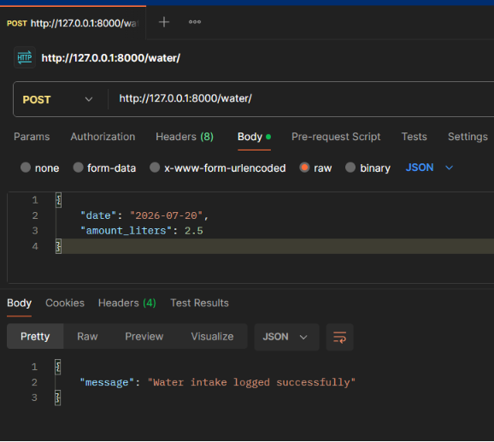

Step 5: Verify Stored Data

Procedure
- Change method back to GET.
- Enter:
http://127.0.0.1:8000/water/
- Click Send.

Expected Output
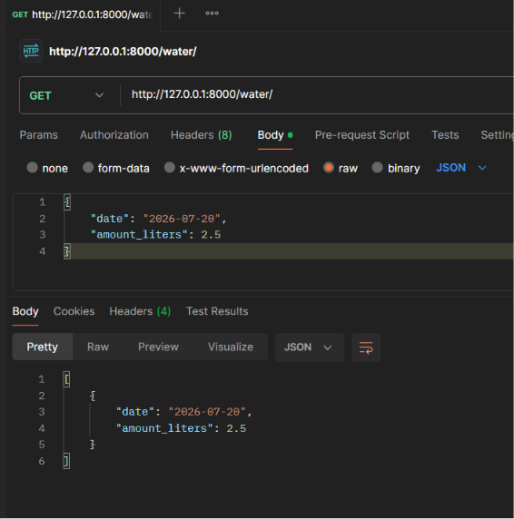
This confirms that the record has been stored successfully.

